For immediate release
PRESS RELEASE
Professor Alison McConnell, Centre for Sports Medicine & Human Performance, Brunel University & Breathe Strong Training

19th April 2012

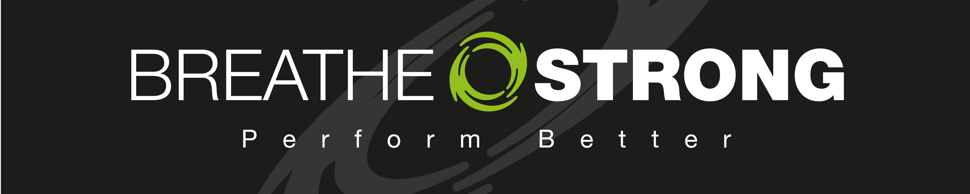


New iPhone App to help you Breathe Strong

If you’re partial to a bit of heavy breathing, then you’ll want to check out this new breathing training App on the Apple App Store. It’s created by breathing training expert, Professor Alison McConnell, author of top selling book “Breathe Strong, Perform Better” (Human Kinetics Inc.).

If you already have a POWERbreathe®, then the new Breathe Strong App makes an ideal training companion. The App provides a comprehensive, but convenient guide to optimising your breathing training with a breathing muscle trainer - it’s packed with information and tips, and also provides a user programmable breathing pacer and counter. This function is not only useful for optimising breathing training, but can also help build breathing control during other workouts. Using the pacer to regulate breathing during workouts builds good breathing habits, replacing the usual “puffing and panting” with deep, slow, controlled breathing.

The Prof also provides some breathing training “top tips”, drawn from 20 years of research, and over 15 years of working in elite sport.

The App is priced at just £1.49, and gives access to the following secrets of optimal breathing training on the iPhone –

· Optimal breathing technique
· Setting the training load
· Optimising repetition failure
· The influence of concurrent training
· Progressing training
· The Prof’s ‘Top Tips’

Just visit the Apple App store and search using "Breathe Strong". An Android version should be available within the next few weeks.
ENDS

Images
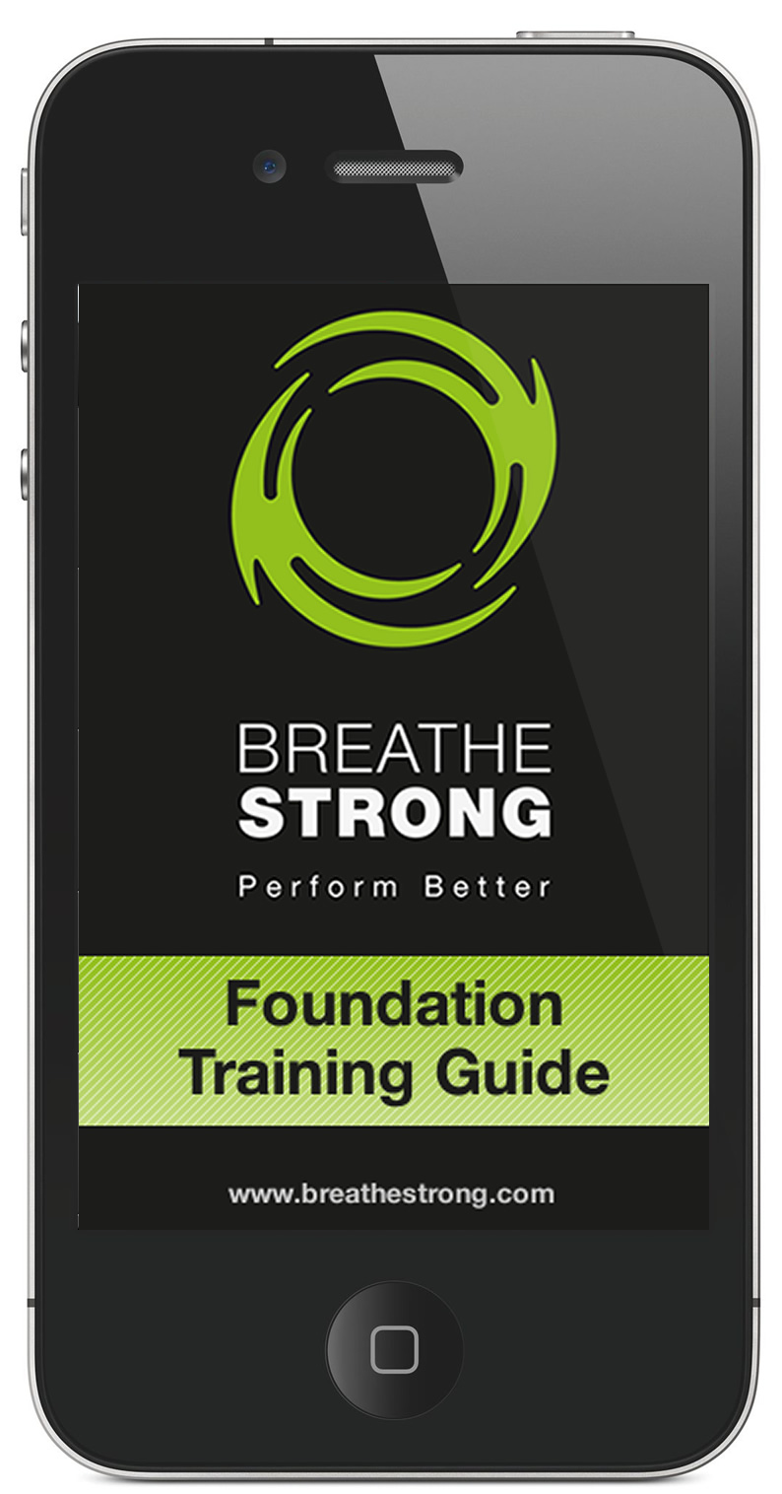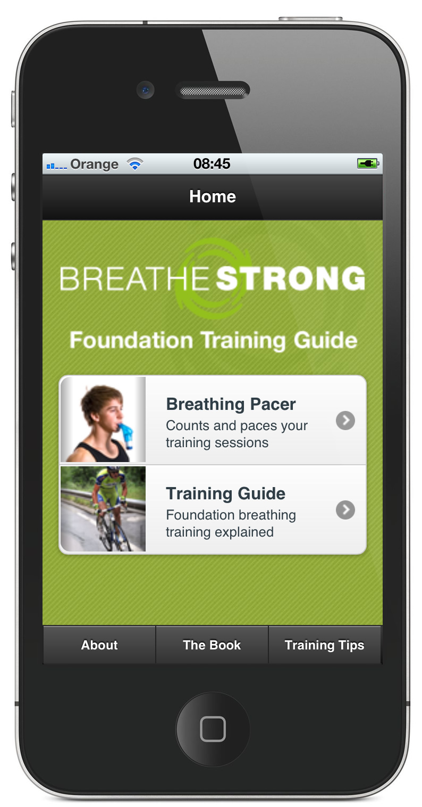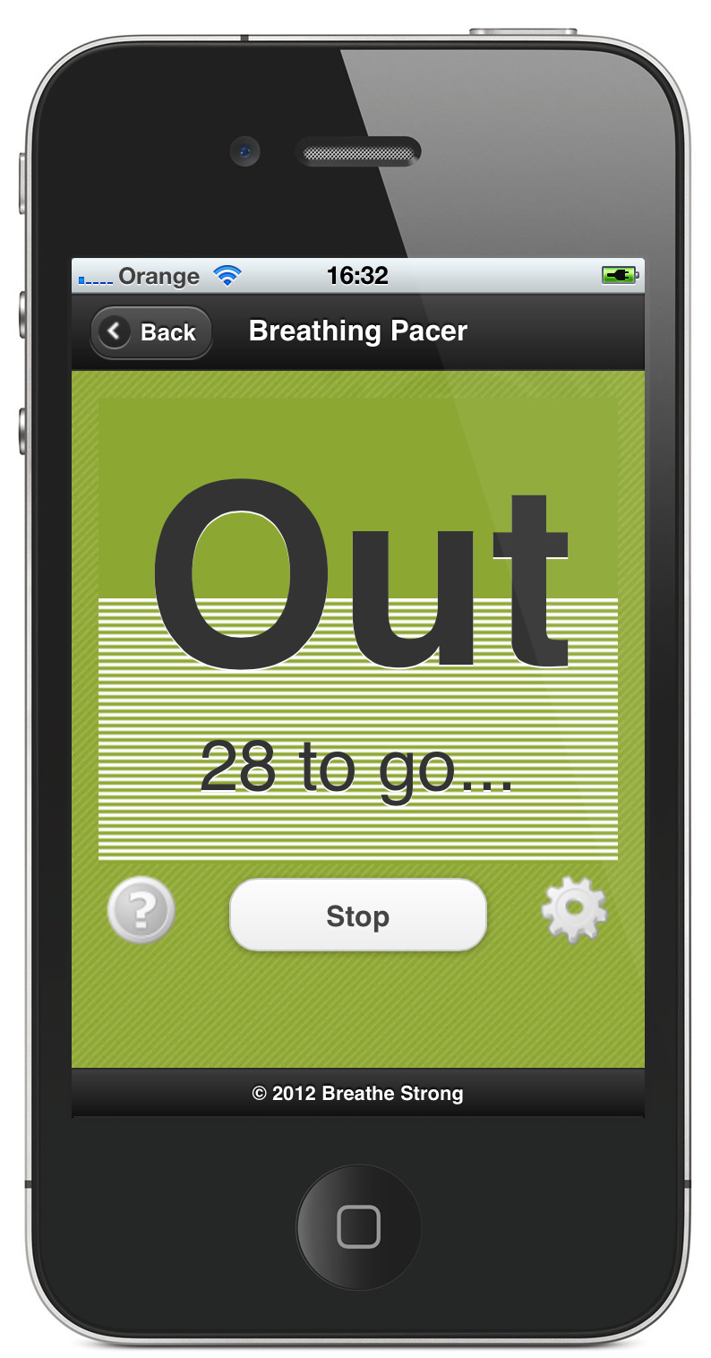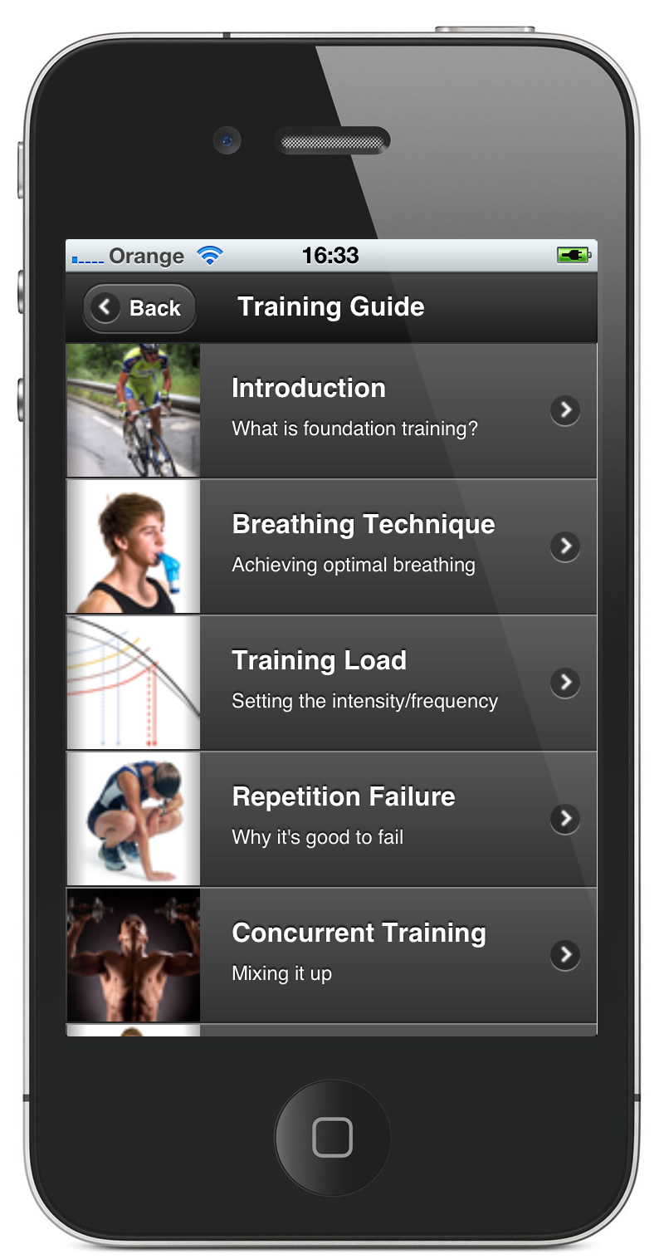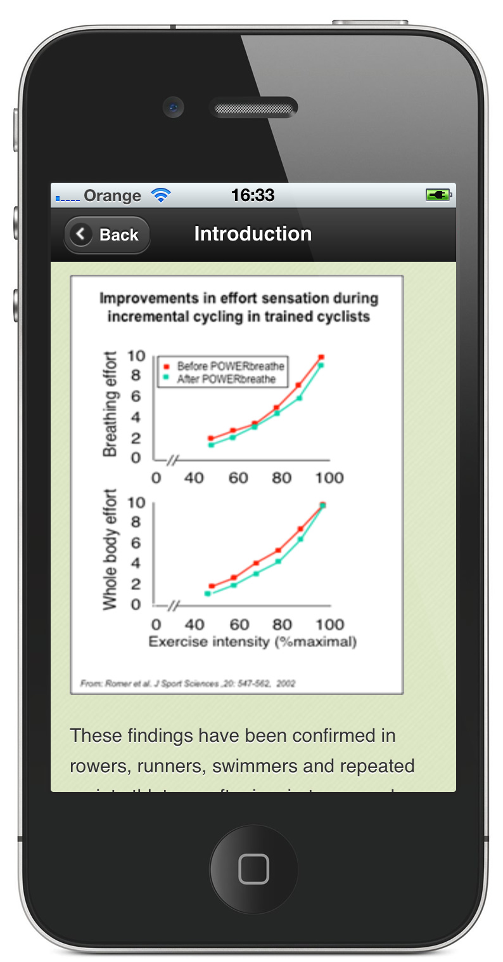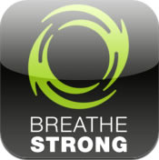

For more information contact Professor Alison McConnell (hello@breathestrong.com, or 07710 198417)

Notes to Editors
Professor Alison McConnell is Professor of Applied Physiology at the Centre for Sports Medicine and Human Performance at Brunel University, London. Alison is the world's leading expert on breathing muscle training. Not only an accomplished academic she is also a successful inventor (www.powerbreathe.com). For more information on Alison please visit –

www.brunel.ac.uk/about/acad/sse/ssestaff/sportsstaff/alisonmcconnell

www.breathestrong.com

http://blog.breathestrong.com

http://itunes.apple.com/us/app/breathing-training/id516684509?ls=1&mt=8

Find out more about breathing training for sport in Alison’s book, “Breathe Strong, Perform Better”, published by Human Kinetics.

